|  |
| --- |
| **STANDARD QUESTIONNAIRE FOR OPEN LAB - PROGRAMME APPLICATIONS**  **Date of filling in this form** |
|  |

For your proposal to be reviewed, please complete all sections in this template. Enter **NA** for any area that is not applicable for your project.

Please, adhere to the word limit for each field. Additional supporting information or data necessary for the review of the project can be attached separately as an appendix.

1. Project Title and summary

2. Project modality

3. Disease

4. Applicant and grants/admin officer contact

5. Describe your project

6. Expected results and impact

7. Work packages/ Gantt Chart/ Deliverables/Milestones/ Critical risks

8. How do you envisage GSK R&D contribution to the project?

9. Resources committed by your group (if any)

10. Additional questions: 13 Y/N questions to have a better understanding about your project

11. Budget

Appendix 1

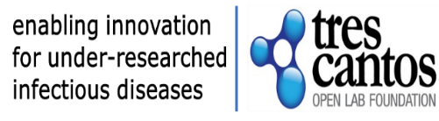

**STANDARD QUESTIONNAIRE FOR OPEN LAB - PROGRAMME APPLICATIONS**

1. project title and summary

Insert your title here.

Provide a summary of your proposed project, describing the rationale, research question/hypothesis, goals and research methods to be used.

*Use Calibri 11* *text format, maximum* ***300 words*** *with spaces, do not use bold.*

4. applicant/s contact and grant/admin officer

*Use Calibri 11 text format do not use bold.*

Name:

Position:

Institution:

Email:

Name:

Position:

Institution:

Email:

Name:

Position:

Institution:

Email:

3. disease



Specify the disease. If other, specify

*Use Calibri 11 text format*

2. project modality. (see appendix 1)

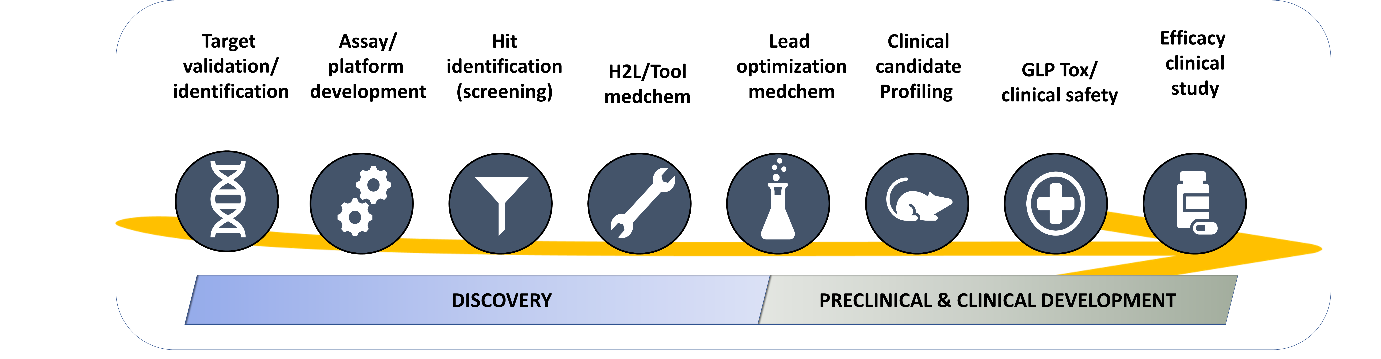

Specify the modality/modalities that apply to your project (specify as many as you need). See Appendix 1 for TCOLF funding schemes and Project modalities description.

*Use Calibri 11 text format*

*.*

5. describe your project

*Use Calibri 11,* maximum of 2000 words, please describe

- Background

- Problem statement and research question(s)

- Project vision/goal

- Scientific rationale

- Study design and methodology including target population, inclusion and exclusion criteria, sample size considerations and clinical endpoints (only for Clinical Development projects)

- Ethical considerations (only for Preclinical & Clinical Development projects)

*You can include figures/reaction schemes or photos.*

6. EXPECTED RESULTS AND IMPACT

Use this space to highlight the outcomes expected at project end, and their potential impact (medium and long term) in the field of your project

Use Calibri 11 text format, maximum 150 words

7. work packages, Gantt Chart, deliverables, milestones, & critical risks

Split the work to be done in work packages and include deliverables, milestones, critical risks and go/no go decision points if applicable. For clarity fill the Gantt chart template.

*Use Calibri 11 text format*

**Work Package (WP) 1**

Title, site, timelines

WP objective and tasks description:

**Work Package (WP) 2**

Title, site, timelines

WP objective and tasks description

**Gant Chart,** (modify as required)

|  |  |  |  |  |  |  |  |  |  |  |
| --- | --- | --- | --- | --- | --- | --- | --- | --- | --- | --- |
| # WP | WP (short) name | months | | | | | | | | Site |
| 01-03 | 04-06 | 07-09 | 10-12 | 13-15 | 16-18 | 19-21 | 22-24 |
| WP1 |  |  |  |  |  |  |  |  |  | GK/Home Institution |
| WP2 |  |  |  |  |  |  |  |  |  | GK/Home Institution |
| WPn |  |  |  |  |  |  |  |  |  | other |
|  |  | |

**List of Deliverables**

|  |  |  |  |  |
| --- | --- | --- | --- | --- |
| **Deliverable number** | **Title** | **Work package number** | **Delivery date**  **(in months)** | **Type:**  **Report / Data set / Publication / Other (specify)** |
|  |  |  |  |  |
|  |  |  |  |  |
|  |  |  |  |  |

**List of milestones**

|  |  |  |  |  |
| --- | --- | --- | --- | --- |
| **Milestone number** | **Milestone name** | **Related work package(s)** | **Due date (in month)** | **Go/no-go milestone? (Y/N)**  If Y: indicate consequence of not reaching the milestone |
|  |  |  |  |  |
|  |  |  |  |  |
|  |  |  |  |  |

**Critical risks for implementation (include delayed progress if relevant)**

|  |  |  |
| --- | --- | --- |
| **Description of risk (indicate level of (i) likelihood, and (ii) severity: Low/Medium/High)** | **Work package(s) involved** | **Proposed risk-mitigation measures** |
|  |  |  |
|  |  |  |
|  |  |  |

**DEFINITIONS**

|  |  |
| --- | --- |
| **Critical risk** | A critical risk refers to a potential event or issue that could significantly impact a project’s ability to achieve its objectives. The likelihood of occurrence is assessed as low, medium, or high, considering any mitigating measures in place. Additionally, the severity of the risk is evaluated based on its relative seriousness and the significance of its effects |
| **Deliverable** | A report sent to TCOLF provides essential information for effective project monitoring. Various types of deliverables, such as reports on specific activities or results, data management plans, and ethics or security requirements, contribute to this process. |
| **Milestone** | Control points within a project serve to track progress. Milestones can align with key results or critical decision points, enabling the transition to the next project phase (with the latter being a go/no-go milestone). Additionally, milestones may be necessary at intermediate stages to address any issues that have arisen. The achievement of a milestone should be verifiable. |

8. how do you envisage gsk r&d contribution to the project?

Use this space to enumerate the benefits for your project to collaborate with industry (platforms, compound collection, scientific and technical expertise, etc).

Use Calibri 11 text format, maximum 200 words

9. RESOURCES TO BE COMMITTED BY APPLICANT’S GROUP

Use this space to enumerate contributions to the project at your home institution in-kind (estimated number of employees, consumables, etc.)

Use Calibri 11 text format, maximum 200 words.

10. additional questions

1. Has the Principal Investigator links with the Government? Y/N
2. Is the Principal Investigator an HCP (Health Care Professional)? Y/N
3. Gender of Principal Investigator (optional, for statistical purposes only):
4. Nationality of Principal Investigator (optional, for statistical purposes only):
5. Has this project been previously submitted, currently funded or supported by, or under consideration for funding or support, from another agency or sponsor? Y/N. If yes, please specify
6. Does the project involve any research work with human biological samples? Y/N

If yes, do the human samples belong to the Home Institution?

If no, please specify source

1. Does the collaboration involve any research work with animals? Y/N

If yes, does the animal work will be performed at the Home Institution?

If no, please specify the facility location

1. Do you foresee any ethics issues in the development of the project (other than 6&7 above)? If so, how do you plan to handle them? (this section can be expanded as necessary)
2. Does your application involve the use of any non-human Genetic Resource (or a derivative)? Y/N
3. Does your Institution (or somebody else) have IP protection on the idea?
4. Does your Institution find acceptable to allocate all IP generated along the Open Lab project to WIPO Re: Search, or equivalent guiding principles.?
5. Only for Preclinical & Clinical Projects: In which countries will research take place?
6. Only for Preclinical & Clinical Development Projects: Will the research proposal involve (underline all that apply)?

HUMAN SUBJECT RESEARCH – HUMAN EMBRYONIC STEM CELLS – VULNERABLE POPULATION (e.g. Children in care, pregnant woman).

*Note: When structures of GSK compounds are required to carry out activities related to Openlab project, these can be provided by GSK after going through internal mandatory processes. The number of structures released will depend on project needs/results and the process to access them will be duly described in the Open Lab Agreement.*

11. budget

|  |  |  |
| --- | --- | --- |
|  | ***Funding requested in GBP*** | ***Description of costs to be funded*** |
| **Personnel costs** |  |  | Maximum personnel costs funded will be of:   * Technician: £ 39,543.64 /year * Degree: £ 45,667.01 /year * PostDoc: £ 60,202.98 /year   Salary will be calculated deducting employer costs (social security contributions, life insurance if provided, etc) from this amount. |
| **Operations** |  |  | E.g. recruitment of participants, administrative costs, courier & shipping of materials , checkups, if needed  Reference for Biocair courier & shipping of material is £2,150 / shipment |
| **Travel** |  |  | Travel to/from Home Institution location   * Open Lab fellow: one round trip; if the project is longer than 24 months, an extra flight can be considered * Project duration more than 18 months: one round trip for the Principal Investigator   Reference for short-haul flights (within Europe) is £300 and for long-haul flights (outside Europe) is £1.000 |
| **Consumables** |  |  | Lab supplies at the home institution |
| **Services** |  |  | Other research costs, e.g., subcontracting/CRO (please specify) |
| **Other costs**  **(specify)** |  |  | Dissemination related expenses such as conference fees, travel to conferences of funded scientists |
| **Subtotal**  **(Institution)** |  |  |  |
| **Accommodation** |  | Number of months in Tres Cantos  OL Fellow 1:  OL fellow 2: | Accommodation during the stay in GSK Global Health R&D Spain will be provided and paid by a TCOLF external supplier, provided that the researcher relocates to one of the flats administered in Tres Cantos. |
| **Open Access** |  | Open Access allowance up to £3,500 will be covered during Grant period and 12 months following completion of the project, 50% will be covered during the second year and 25% in the third year | |
| **Total grant** |  |  | |

Appendix I

PROJECT MODALITIES

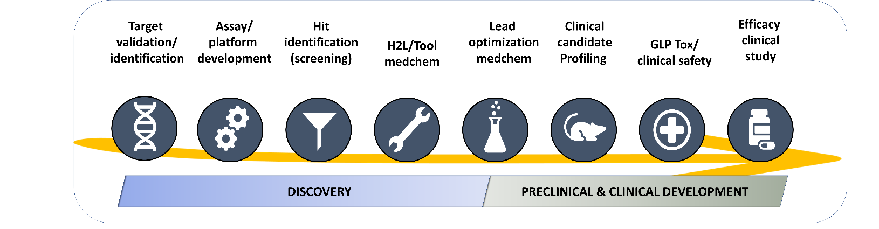Projects in scope include innovative approaches in the field of endemic infectious diseases that could offer a new solution to an existing gap that can benefit from collaboration with the pharma industry in the fields of gut health (including bacterial enteric infections and environmental enteric dysfunction, EED), malaria, tuberculosis, and kinetoplastid mediated infections. In addition to discovery projects, since April 2019 TCOLF is accepting applications in the translational and clinical (up to Ph2a) space.

**Discovery Projects**: Co-location is a key factor for eligibility. The maximum budget is expected to be ≤ £200K.

**Preclinical and Clinical Development projects**: Co-location is not expected. Due to the greater anticipated cost of these projects, the scope will be restricted to: advanced lead molecules (robust in vivo activity on relevant models with a clear developable profile), clinical candidates, and repurposing opportunities. The maximum budget is expected to be ≤ £500K.

**Target validation / identification**: Projects in scope include generation of chemical probes for chemical validation of novel genetically validated targets and the use of chemoproteomic approaches for target identification/engagement.

**Assay / platform development**:Development and miniaturization of quantitative assays for screening (LTS, MTS, HTS) or medicinal chemistry programs.

**Hit Identification**: Screening campaigns of focus compound sets and / or diversity compound sets from the GSK collection.

**H2L / tool optimization**:Program focused on optimizing a molecule (*in vitro active* with none or poor *in vivo* activity) to deliver a selective (in the case of target base programs) advance analogue with a Pharmacokinetic compatible with an oral dosing for proof of concept in animal model (lead compound).

**Lead optimization**:Medicinal chemistry program focused on optimizing a lead/s molecule/s (*in vivo active*) to deliver a new analogue with a robust in-vivo efficacy subjected to full *in vivo* pharmacological profiling for the target indication and a tailored toxicological safety assessment to finally qualify as a clinical candidate. Depending on the candidate-likeness of the lead molecule, the project can be considered Discovery Projects or Preclinical & Clinical Development Projects

**Clinical candidate profiling**:Tailored plan to evaluate potential clinical candidates (small molecules, biologicals, etc). Projects on scope include non-GMP scale-up, tailored non-GLP *in vivo* preclinicalsafety and/or efficacy studies.

**GLP Tox / clinical safety**:Tailored plan to evaluate clinical safety of novel candidates (small molecules, biologicals, etc). Projects on scope include GMP scale-up, tailored GLP *in vitro* and *in vivo* safety studies and Clinical safety (Phase 1 studies)

**Efficacy clinical studies**: Tailored clinical Probe of Concept (Phase 2 studies).